

UNIVERSITY OF THE EAST
CALOOCAN CITY
College of Engineering
Department of Computer Studies and Systems

STATIC ROUTING
Packet Tracer Activities

Name: Dela Cruz, Juan F.
Student Number: 199*****
Subject and Section: CIT2201 – IT--

Activity No. | Score
ACT1
ACT2
ACT3

Activity 01 (SAMPLE ONLY)
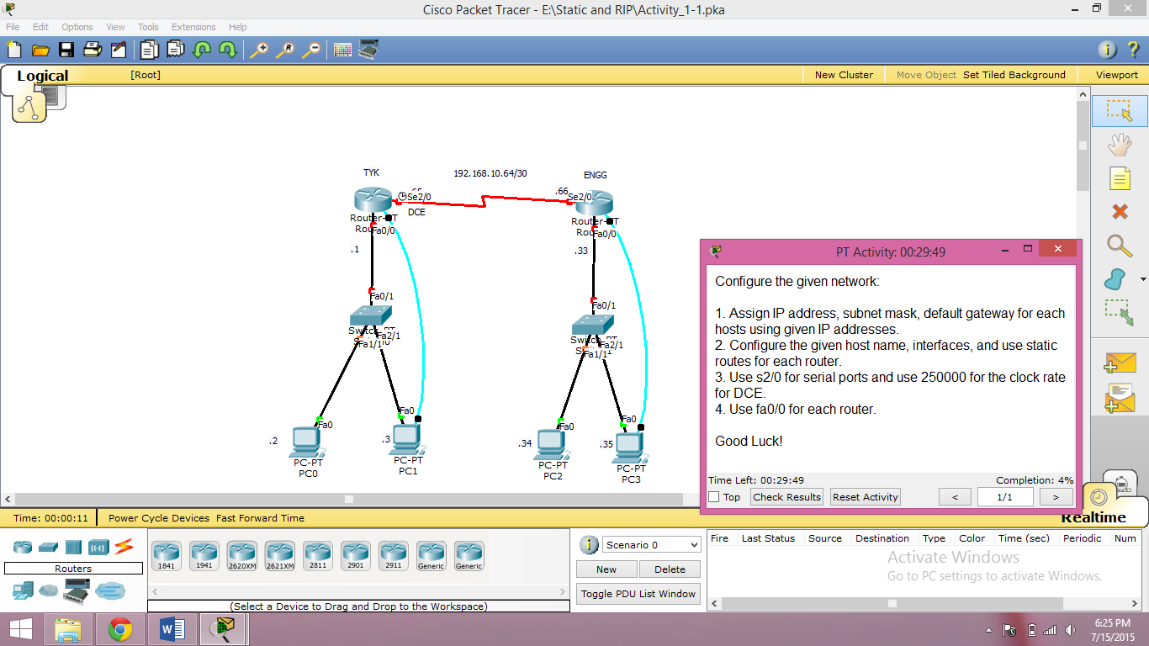

Router>fgdsg
Translating "fgdsg"...domain server (255.255.255.255) % Name lookup aborted
Router>en
Router#conf t
Enter configuration commands, one per line. End with CNTL/Z.
Router(config)#252
^
% Invalid input detected at '^' marker.
Router(config)#5452
^
% Invalid input detected at '^' marker.
Router(config)#525
^
% Invalid input detected at '^' marker.
Router(config)#325
^
% Invalid input detected at '^' marker.
Router(config)#32523
^
% Invalid input detected at '^' marker.
Router(config)#523
^
% Invalid input detected at '^' marker.
Router(config)#54
^
% Invalid input detected at '^' marker.
Router(config)#534
^
% Invalid input detected at '^' marker.
Router(config)#54
^
% Invalid input detected at '^' marker.
Router(config)#53
^
% Invalid input detected at '^' marker.
Router(config)#34
^
% Invalid input detected at '^' marker.
Router(config)#tewgds
^
% Invalid input detected at '^' marker.
Router(config)#gdsf
^
% Invalid input detected at '^' marker.
Router(config)#ht
^
% Invalid input detected at '^' marker.

Router(config)#g
^
% Invalid input detected at '^' marker.

